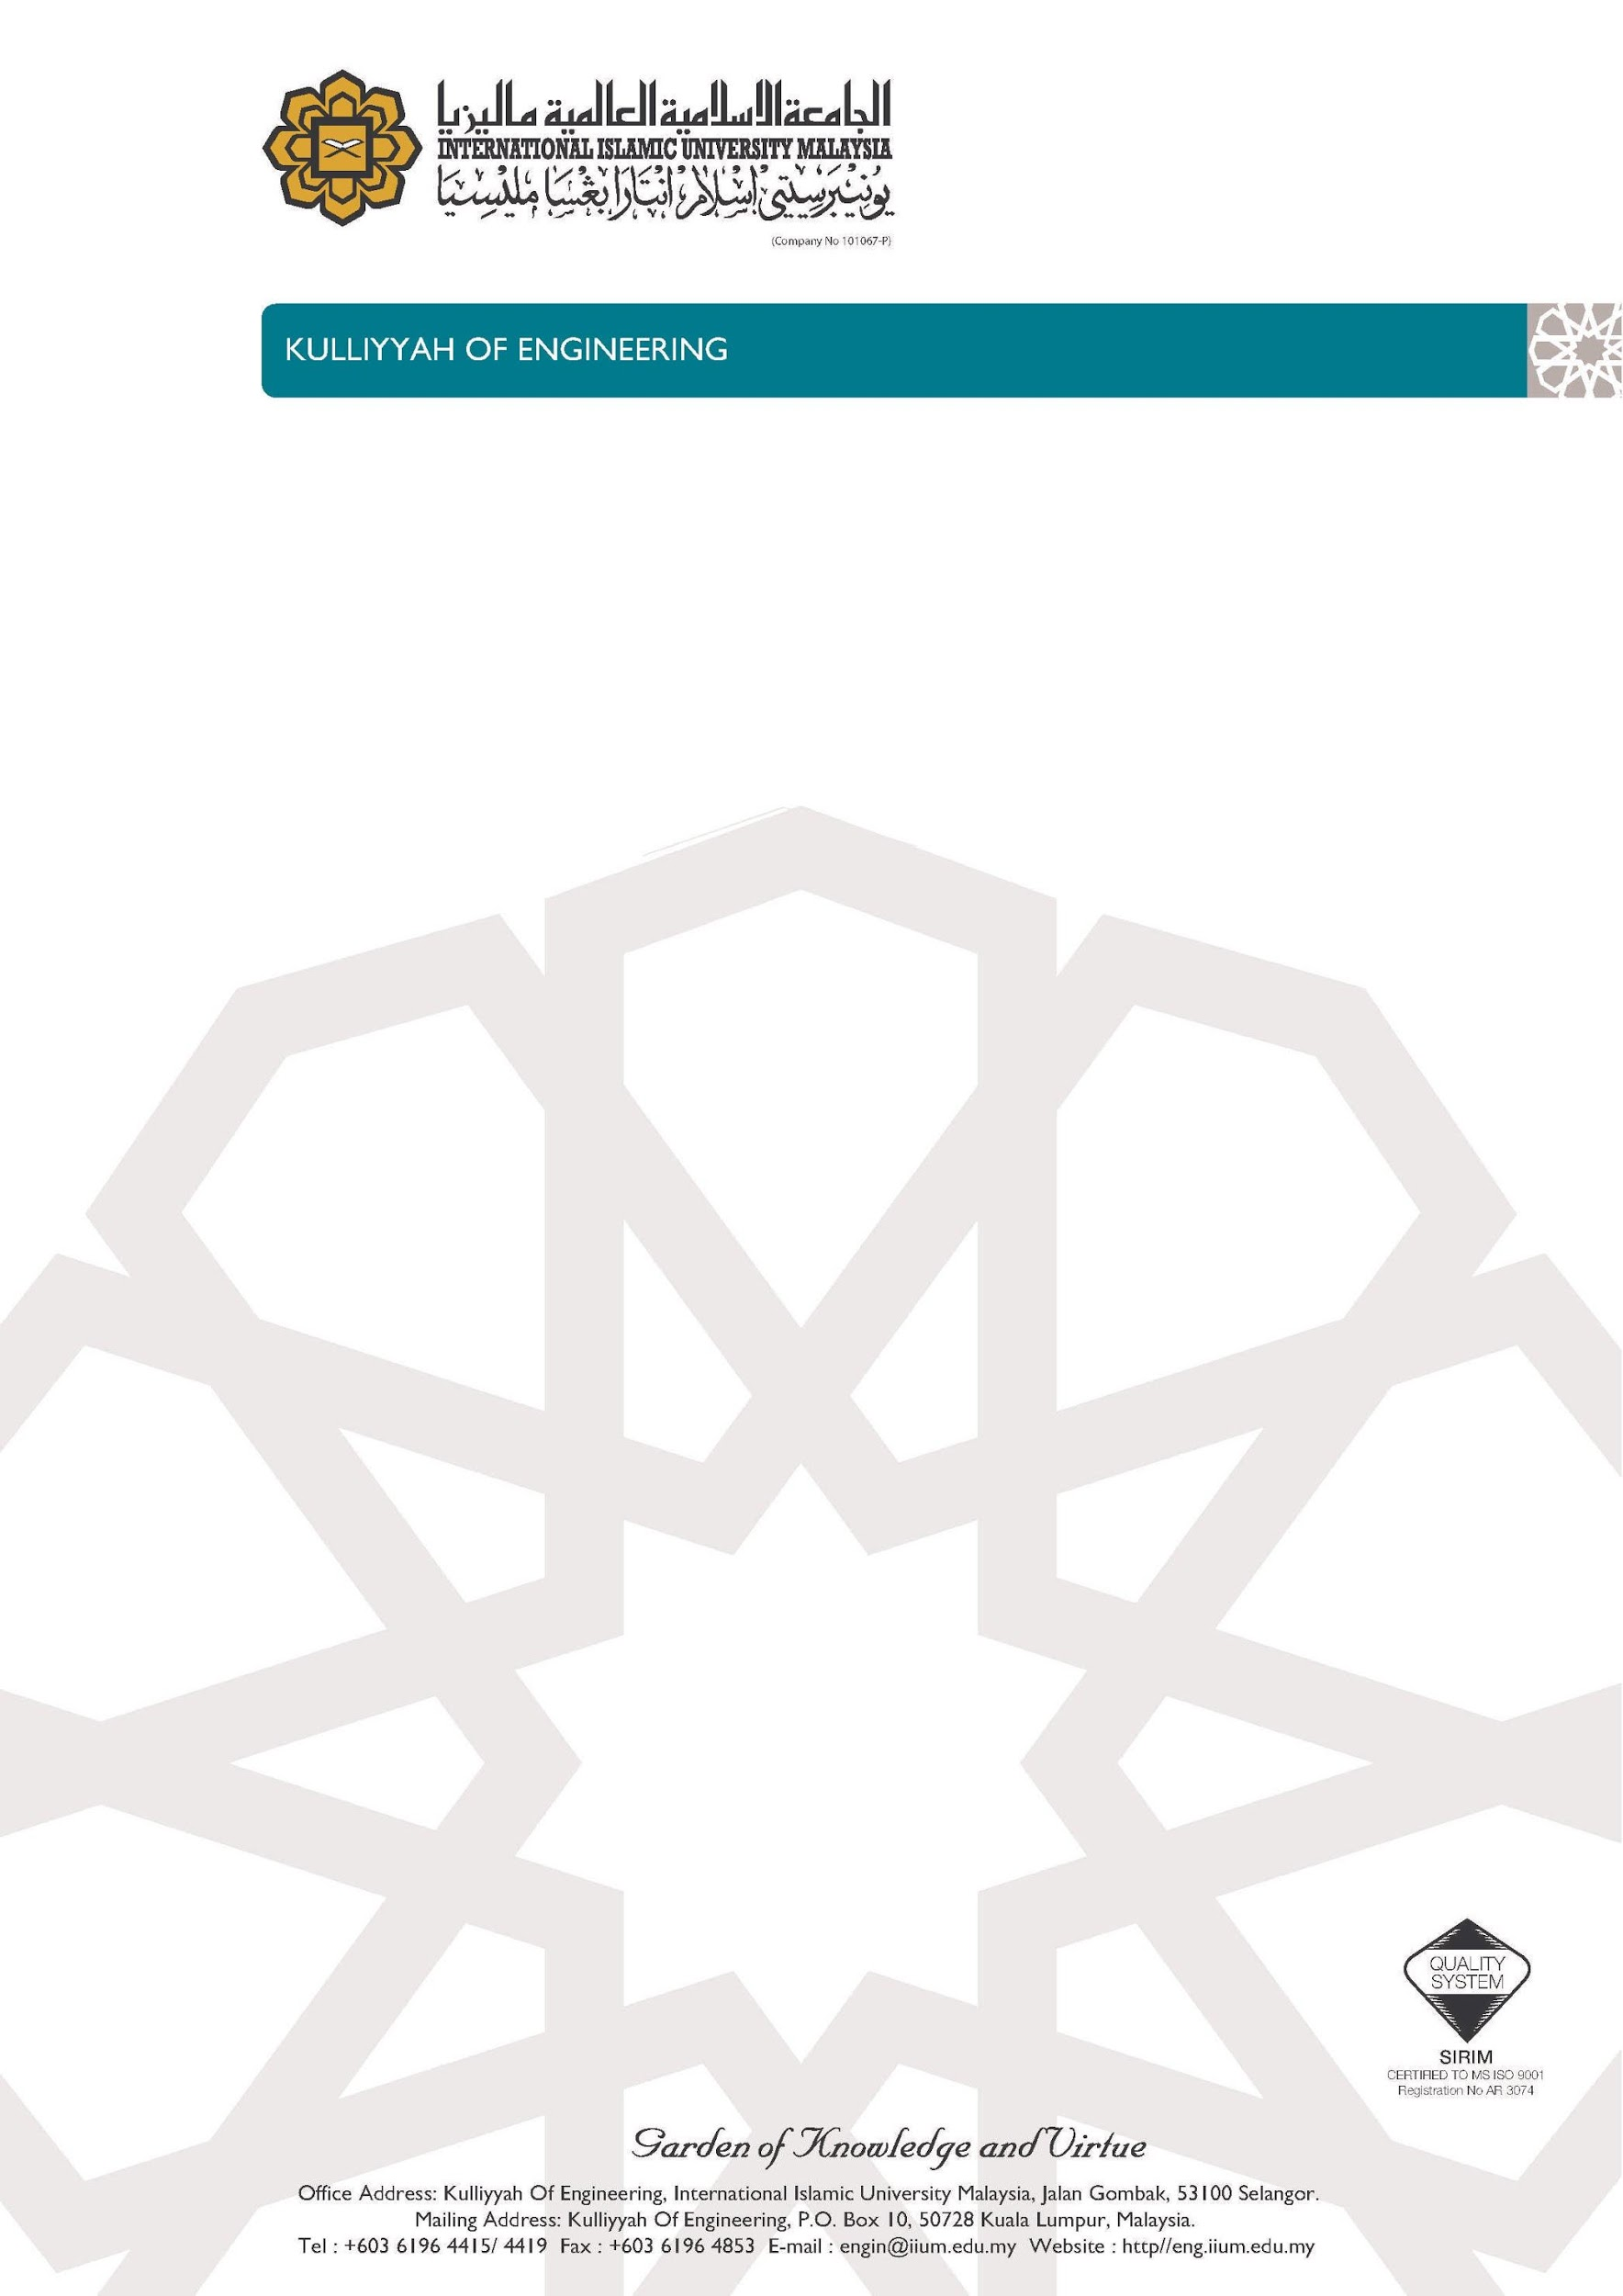

*Our Reference: ROBOCON/1/2019 Date: 7 October 2019*

Dear Sir/Madam,

**REQUEST TO USE HOBBY SHOP**

On behalf of Kuliyyah of Engineering (KOE), I would like to request for our Roboteam members to use your Hobby Shop located at Kuliyyah of Architecture and Environmental Design for the preparations of ABU ROBOCON Malaysia 2020.

2. ABU ROBOCON Malaysia is one of the biggest robotic competition in Malaysia. IIUM Roboteam proudly managed to get the second runner up for ABU ROBOCON Malaysia 2018. For ABU ROBOCON Malaysia 2020, our team are already preparing for the competition. Thus, I would like to request your good office to allow us to use your Hobby Shop as our game field and to practice for our upcoming competition on April 2020. The game field will be used throughout the duration of our preparations for the competition. Below are the details of our request:

Requested Venue : Hobby Shop, Kuliyyah of Architecture and Environmental Design (KAED)

Date : December 2018 until April 2019

3. We would like to use your Hobby Shop because our robots need a huge space and a place to practice for the competition. Our Robot Design Lab at E2, KOE is not big enough to build the game field and it is not suitable for making large projects. We also have included the game field’s top view with dimension in Appendix A.

4. We are looking forward for your consideration and approval. Your huge contribution might make IIUM be the winner of ABU ROBOCON Malaysia 2020.

Thank you.



Sincerely,

………………………………….....

Assistant Professor Dr Ahmad Imran bin Ibrahim,  
Advisor of IIUM ROBOCON 2020 Team,    
IIUM Roboteam,

International Islamic University Malaysia.

*APPENDIX A*

